Annual Project Progress Report

Project title: Strengthening the Trade Capacity of Turkmenistan
Award ID: 00097116
Project ID: 00100961
Implementing partner: Ministry of Trade and Foreign Economic Relations of Turkmenistan

Period covered in this report: January – December 2021
Date of last Annual Report: December 2020
Date of the last Project Board meeting: 28 October 2021

Date of last Qaulity Assurance and rating: January 2021, satisfactory

1.Project Performance

Please state the expected Output of the Project, set indicators and corresponding CP Outcome (as per project document/AWP):
Project Output 1: Strengthening institutional and personal trade capacity
Output indicators:

1.1. Capacity building of national staff on application of advanced informational and marketing technologies for analyzing market and consumer behavior and organizing sale of goods, in velayats;
1.2. Carrying out of certified course on professional development in the area of international trade;
1.3. Development of proposals on improvement of practice of concluding international agreements on trade and economic cooperation on bilateral, regional and multilateral basis.

Output targets:

b) Were the indicators and output achieved? Yes No Partially
c) If no or partially, please explain why?

Output indicators 1.1. and 1.3. were fully implimented and output 1.2. were partially achieved. International consultant was contracted to perform output indicator 1.2.however, due to technical reasons could not be realized.

Project Output 2:
Output indicators:

2.1. Development of proposals on elimination of trade barriers and implementation of comprehensive system to support national export throughout the whole goods shipment chain; International experience and recommendations for Turkmenistan;

2.2. Review and preparation of proposals to improve the trademark registration practice;

2.3. Recommendations on increasing practical results of activities of trade houses located abroad have been prepared;

Output targets:

b) Were the indicators and output achieved? Yes No Partially
c) If no or partially, please explain why?

Output indicators for 2.2. and 2.3. were fully achieved but 2.1. was partially achieved due to technical reasons.

Project Output 3: Strengthening of applied scientific research capacity
Output indicators:

3.1. Proposals on strengthening research and innovation component in the activities of Ministry of Trade and Foreign Economic Relations of Turkmenistan through implementation of public-private partnership mechanism

3.2. Preparation of proposals on concluding cooperation agreements between the Ministry of Trade and Foreign Economic Relations of Turkmenistan and international research and expert organizations

3.3. Development of proposals on improvement of international logistics system and implementation of innovative management in the trade system of Turkmenistan

Output targets:

b) Were the indicators and output achieved? Yes No Partially
c) If no or partially, please explain why?

Output indicator 3.1. was fully implimented and output indicators 3.2. and 3.3. were cancelled with the suggestion of national partner as those targets were not fully in line with the functions of the implimenting partner.

2.Progress Reporting
Please summarize the main achievements during the project cycle:
Project Output 1:
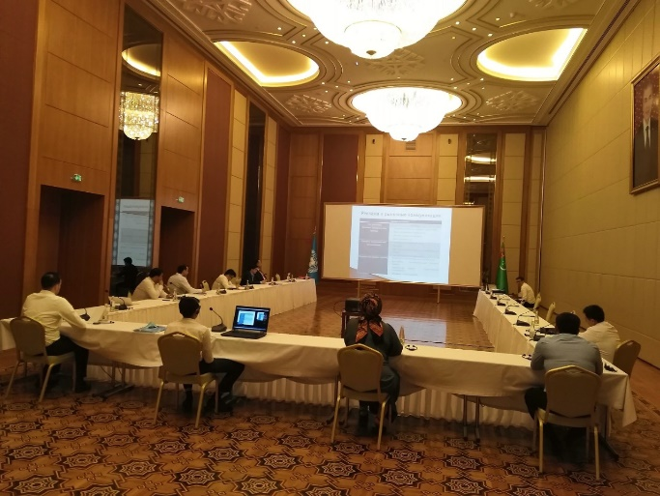
Output indicator 1.1.: Continuing with Covid-19 restrictions into 2021, within the joint project maximum efforts being applied to impliment activities agreed for Annual Work Plan 2021 with national partner in online mode. From 06 to 26 of May 2021, in hybrid format 3 days training in each region of the country with participation of international expert Mr. Ravinder Raina were organized on the application of advanced informational and marketing technologies for analyzing market and consumer behavior and organizing sale of goods for spcialists of Dashoguz, Lebap, Ahal, Mary and Balkan velayats. Participants were aquainted with basic modern marketing concepts and techniques and application of advanced technologies in trade and commerce. Specialists of national partners learnt the best international practices, trends and developments in e-commerce and how to develop e-commerce at individual firm and national levels. In the serious of trainings, 15 participants attended from each velayat making 75 individuals in total. Participants mainly were heads of sections and specialists of velayat departmnets from Turkmenistan Ministry of Trade and Foreign Economic Relations, State Commodity and Raw Materials Exchange, Chamber of Commerce and Industry, Union of Industrialists and Entrepreneurs and Ministry of Finance and Economy. At the end of training all participants recieved certificate of attendence. Relvant activities press release is published in following UNDP site: UNDP facilitates trade development in Turkmenistan | UNDP in Turkmenistan.

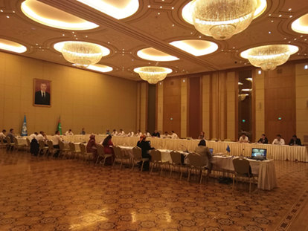
Output indicator 1.2.: From 21-25 June 2021 in hybrid format foreign trade policy development training was organized for 36 spesialists and heads of sections from the line of ministries and organizations of Turkmenistan such as Ministry of Foreign Affairs, Ministry of Trade and Foreign Economic Relations, Ministry of Finance and Economy, Ministry of Agriculture and Environmental Protection, Ministry of Industry and Construction Production, State Commodity and Raw Materials Exchange, Chamber of Commerce and Industry, Union of Industrialists and Entrepreneurs, State Customs Service, Main State Service of Turkmenistan „Turkmenstandards“. Mr. Achim Seiler, international consultant from Germany introduced the World Trade Organization and instructed participants of the training with important processes to prepare country’s rediness to WTO accession in the future. Participants of the training were exposed to the essense of formulating foreign trade policy with consideration of WTO membership. Participants of the training engaged in productive discussions with the international consultant. Mr. Seiler provided considerable amount of information and instructions for further study of WTO training and cources. The training was part of a certified course to develop trade skills of national partners. Press release on this event can be found at UNDP supports development of the country’s trade sector | UNDP in Turkmenistan.

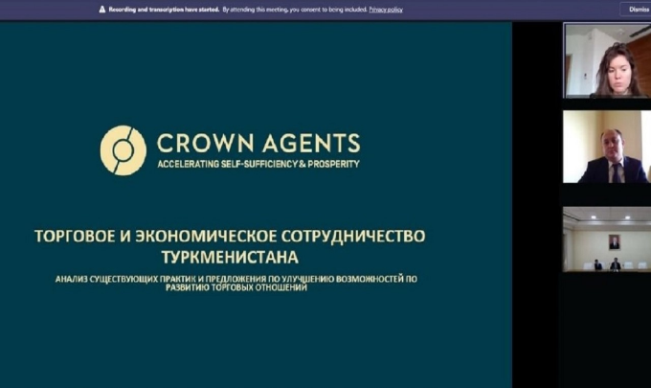
Output indicator 1.3.: Implimentation of this output indicator was carried out by the international experts of British „Crown Agents“ company. Within the framework of this activity with the support of national consultant international experts of the „Crown Agents“ company Ms. Evgenia Pomerlyan and Mr. Vladimir Trofimchuk developed proposal on improvement of practice of concluding international agreements on trade and economic cooperation on bilateral, regional and multilateral basis. Online seminar was held on 12th of October 2021 to present proposal to national partners. The event coverage for press release can be viewed at UNDP supports improvement of practices of concluding international agreements on trade and economic cooperation | UNDP in Turkmenistan. In cooperation with national partners from the Ministry of Trade and Foreign Economic Relations, Ministry of Foreign Affairs, Ministry of Justice, Ministry of Finance and Economy, Ministry of Agriculture and Environmental Protection State Commodity and Raw Materials Exchange, Chamber of Commerce and Industry, Union of Industrialists and Entrepreneurs, State Customs Service, State Sanitary Epidemiological Services and other national partners model agreement was drafted based on the recommendations of international experts.

Project Output 2:

Output indicator 2.1.: For the implimentation of this output indicator, international post was announced, scorings of candidates were processed but not contracted due to technical reasons.

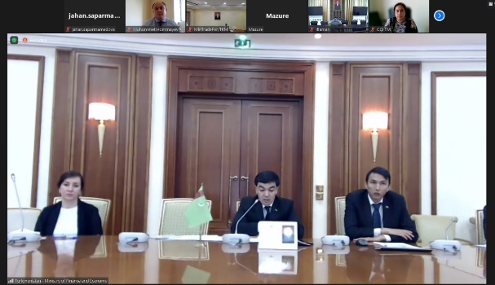
Output indicator 2.2.: For the implimentation of this activity with the support of national consultant, international consultant Ms. Linda Mazure reviewed existing practices of trademark registration in Turkmenistan and developed proposal for improving trademark registration based on the best international practices. Proposal was presented during the online seminar on 16th of August 2021 with participation of the Ministry of Trade and Foreign Economic Relations, State Service for Intellectual Property of the Ministry of Finance and Economy, State Commodity and Raw Materials Exchange, Chamber of Commerce and Industry, and the Union of Industrialists and Entrepreneurs of Turkmenistan. Press release of the seminar can be found at UNDP to improve trademark registration practices | UNDP in Turkmenistan.

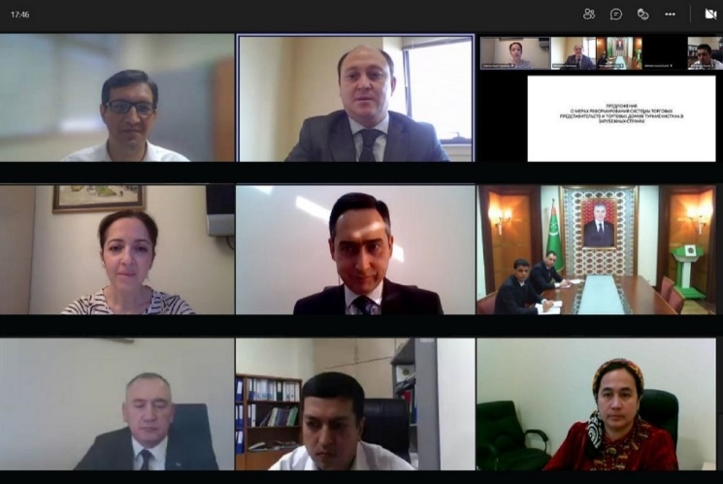
Output indicator 2.3.: This activity was implimented within the framework of „Russian Experts on Demand“ programme of UNDP Russia, financed by the government of Russian Federation. International consultant Mrs. Anait Smbatyan was contracted to review the performance of trade houses of Turkmenistan abroad with the support of national consultant and to provide with recommendations on increasing practical results of activities of trade houses located abroad. As a result, Mrs. Smbatyan prepared the recommendations and delivered her presentation in online seminar on 8th of November 2021. The event gathered the representatives of the line ministries and entities of Turkmenistan, including the Ministry of Trade and Foreign Economic Relations, Ministry of Agriculture and Environmental Protection, Ministry of Finance and Economy, Ministry of Textile Industry, State Commodity and Raw Materials Exchange, State Customs Service, Main State Service "Turkmenstandartlary", State Bank for Foreign Economic Affairs, Chamber of Commerce and Industry, State Service for Sanitation and Disease Control and the Union of Industrialists and Entrepreneurs of Turkmenistan. Press release of the event is available at UNDP supports the improvement of trading houses performance | UNDP in Turkmenistan.

Project Output 3:

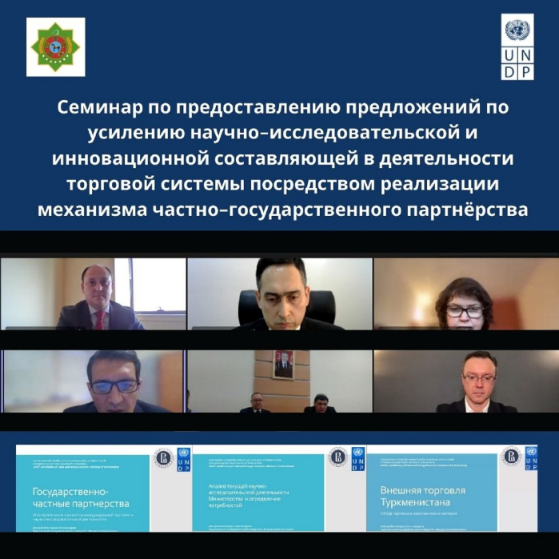
Output indicator 3.1.: Purpose of this indicator was to provide with proposals on strengthening research and innovation component in the activities of Ministry of Trade and Foreign Economic Relations of Turkmenistan through implementation of public-private partnership mechanism. National Research University "Higher School of Economics” of the Russian Federation was contracted to perform the assignment. Professors of HSE, Ms. Elena Shadrina and Mr. Dmitri Vinogradov were the international experts and in joint cooperation with national consultant they explored the Ministry’s current scientific-research activities in study of trade. Proposals developed by international experts of „Higher School of Economics“ were presented in the online seminar which was held on 24th of November 2021. Ministry of Trade and Foreign Economic Relations, Ministry of Finance and Economy, Ministry of Education, State Commodity and Raw Materials Exchange, Chamber of Commerce and Industry and the Union of Industrialists and Entrepreneurs of Turkmenistan participated in the event. Press release of the online seminar available at UNDP improves the scientific-research and innovation activities in trade | UNDP in Turkmenistan.

Output indicators 3.2. and 3.3. were requested to be cancelled by the national partner as those activities were no longer under direct work carried by the Ministry of Trade and Foreign Economic Relations of Turkmenistan.

3. Project Risks and Issues

The project Risk Log is maintained throughout the project implementation to capture potential risks to the project and associated measures to mitigate risk.The Project Manager shall maintain and update the Risk Log and ensure that risks are identified, communicated and managed effectively.

A number of potential risks are listed below.

Description of risk | Type and category | Risk management actions | Current situation
Payment of second usd installment | Low likelyhood | Speeding up payment of second usd installment was requested during Project Board meeting on 12 Febuary 2021 | Risk was mitigated and payment was delivered from national partner in September month of 2021

4.Lessons learned and follow-up steps (if applicable)
a) Please provide the lessons learned and further steps after the project’s closure.
- One of the lessons learned from this project is provision of digital infustructure among national partners. As digitilization expands globally and digital technologies are widely used, it is esstntial that digital equipment are available, internet communication is stable and all personal are able to work with digital technology. In accordance with the new realities, it is necessary to optimize the implementation of project activities in an online format, taking into account the wishes and interests of national partners.

- Balance of work and time allocated for training should be flexible. Flexibility to provide mobile learning and training. Hence, rather than physical gathering and taking time of governmnet officials, e-learning with and without instructor to be incorporated to projects. It is recommended expanding and deepening cooperation with educational and specialized organizations in the field of trade to further strengthen the human, institutional and research potential of the national partners.

- There is a need to continue partnerships with international organizations to implement the Foreign Trade Strategy of Turkmenistan for the period 2021-2030, taking into account the requirements of the WTO membership accession process.

5.Transfer of Assets or other related matter
a) Please state on any past or future transfer of assets made within the project cycle (Attach list of equipment, cooperation frameworks with beneficiaries, etc.)

⃰ Please refer to attached annex I. Asset List for Trade Project.
6.Financial management

Budget item | Total approved in 2021 (in USD) | Expenses + commitments | Budget utilization in % to planned
Component 1 | 150,275 | 146,108 | 97%
Component 2 | 107,334 | 35,481 | 33%
Component 3 | 108,659 | 27,753 | 22%
Total delivery in 2021 | 366,268 | 205,342 | 56%
In % to total project budget | 78% | 44%

Prepared by:______________________Project Manager

Date:25/12/2021

Approved by:____________________ Programme Spesialist

Date: 28/12/2021

